**SmartPik: Q-Com Comparable App**

**Problem Statement**

In today’s fast-paced digital economy, consumers in India face significant challenges when shopping for groceries and everyday essentials online. With the rise of multiple quick-commerce platforms such as Zepto, Blinkit, BigBasket, and others, users often spend an excessive amount of time comparing prices across these platforms to find the best deals. This process is not only time-consuming but also frustrating, as prices and discounts vary significantly between platforms. Additionally, due to the lack of a centralized tool for price comparison, users often end up purchasing products at higher prices without realizing that better deals are available elsewhere. This issue is particularly critical in India, a highly price-sensitive market where consumers prioritize affordability and value for money. The absence of an efficient solution to compare prices across platforms leads to:

**Wasted Time**: Users manually check multiple apps or websites to compare prices, which is inefficient and tedious.

**Higher Costs**: Without a clear overview of prices, users may unknowingly purchase products at higher rates.

**Missed Discounts**: Users may miss out on platform-specific discounts, coupons, or promotions that could save them money.

**Poor Shopping Experience**: The lack of a seamless price comparison tool results in a fragmented and frustrating shopping experience.

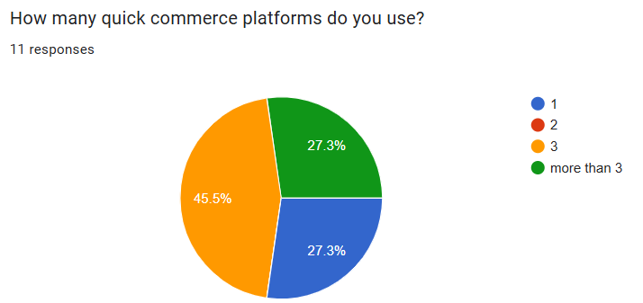

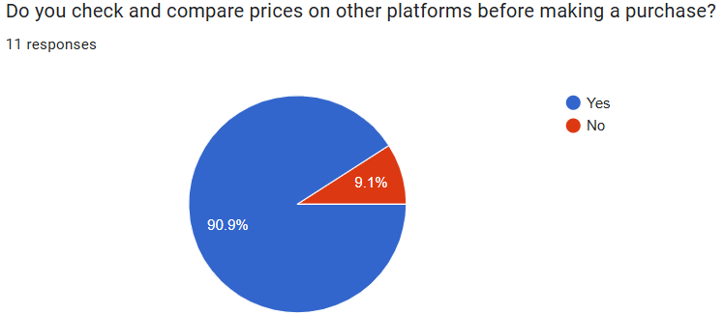

**Solution**

To address these challenges, there is a pressing need for a quick-commerce price comparison app that allows users to:

* **Create a unified shopping list.**
* **Compare real-time prices across multiple platforms.**
* **View the total cost of their shopping list on each platform.**
* **Make informed decisions by selecting the most affordable option.**
* **Seamlessly redirect to the chosen platform for checkout**.

**Ideation stage**

1. **Open App**
2. **Grocery List Creation**:
   * Allow users to add items manually
3. **Price Comparison**:
   * Fetch real-time prices from multiple quick-commerce platforms (e.g., Zepto, Blinkit, BigBasket).
4. **Total Price Calculation**:
   * Calculate the total cost of the shopping list on each platform.
5. **Platform Selection**:
   * Let users choose the platform they want to buy from.
   * Show the options to user
6. **Redirection to Platform**:
   * Redirect users to the selected platform’s shopping cart with their items pre-filled (if possible).

**Design the User Experience**

1. **Grocery List Input**:
   * Provide an intuitive interface for adding items (e.g., search bar).
2. **Price Comparison Table**:
   * Display a table with the total price for the shopping list on each platform.
   * Highlight the cheapest, fastest option.
3. **Platform Selection**:
   * Add a “Buy Now” button for each platform.
4. **Redirection**:
   * Ensure a seamless transition to the selected platform’s app or website.

**Challenges and Solutions**

1. **Data Access**:
   * Challenge: Platforms may not provide APIs or restrict scraping.
2. **Real-Time Updates**:
   * Challenge: Fetching real-time data can be resource-intensive.
3. **Product Matching**:
   * Challenge: Matching products across platforms (e.g., different names or units).

**USER Workflow**

1. **User Action**:
   * A Ram adds the following items to their grocery list:
     + Milk
     + Bread
     + Eggs
     + Apples
2. **Price Comparison**:
   * The app fetches prices from Zepto, Blinkit, and BigBasket:
     + Milk: Zepto (20), BigBasket (19)
     + Bread: Zepto (10), BigBasket (10)
     + Eggs: Zepto (10), BigBasket (8)
     + Apples: Zepto (30), BigBasket (28)
3. **Total Basket Cost**:
   * The app calculates the total cost for the entire list at each platform:
     + Zepto: 70 , delivery time: 7min
     + Blinkit: 77 , delivery time: 11min
     + BigBasket: 65 , delivery time: 30 -60min
4. **User selection:**
   * The Ram clicks can select platform from where they want to buy
5. **Redirection**:
   * The Ram clicks “**Buy Now**” and is redirected to app or website with the items pre-filled in the cart.